 | Testing and Training Center of Farm Machinery  Department of Farm Machinery and Power Engineering  College of Agricultural Engineering and Technology  Junagadh Agricultural University  JUNAGADH – 362 001 (GUJARAT) | 
P | Phone : (0285) 2672080-90, Ext. 390 & 484; Fax : (0285) 2671018

SPECIFICATION SHEET OF TRACTOR OPERATED ROTAVATOR

1.0 | General | :
 | Name | :
 | Type | :
 | Make | :
 | Serial Number | :
 | Model
 | Year of manufacture
 | Name and address of manufacture
 | Source of power
 | Recommended power of tractor, if tractor operated
 | Selling price in India

2.1 | Main frame / Chassis:
 | a) |  | Type and material | :
 | b) |  | Size of box section(mm) | :
 | c) |  | Size of supporting flat (mm)
 | d) |  | Type of mounting box section
2.2 | Side support / plates:
 | a) |  | Number and material | :
 | b) |  | Thickness of plate (mm) | :
 | c) |  | Size (mm)
 |  |  | LHS | :
 |  |  | RHS | :
 | d) |  | Method of fixing | :
2.3 | Shield (cover):
 | a) | Type |  | :
 | b) | Size (mm)
 | c) | Thickness of sheet (mm) |  | :
 | d) | Method of mounting |  | :
2.4 | Trailing board:
 | a) | Type and material |  | :
 | b) | Size of board (mm) |  | :
 | c) | Type and number of hinge |  | :
 | d) | Angle of trailing board |  | :
 | e) | Provision for locking |  | :
 | f) | Method of fixing |  | :
2.5 | Rotor shaft: |  |  | :
 | a) | Material |  | :
 | b) | Type and size (mm) of rotor axle |  | :
 | c) | No. and type of flanges |  | :
 | d) | Size (mm) of flanges |  | :
 | e) | No. of blades on each flange |  | :
 | f) | Total No. of blades |  | :
 | g) | Method of mounting blades on flange |  | :
 | h) | Distance between two flanges (mm) |  | :
 | i) | Dia. of rotor with blades (mm) |  | :
 | j) | Method of fixing |  | :
2.6 | Rotor blade
 | a) | Number and Type |  | :
 | b) | Material |  | :
 | c) | Size (cm) |  | :
 | d) | Thickness (mm) |  | :
 |  | Overall |  | :
 |  | Beveled edge |  | :
 | e) | Length and width of beveled edge (mm) |  | :
 | f) | No., size and spacing of the holes on each blade for fixing it to the flanges (mm) |  | :
 | g) | Arrangement of blades on the axle
2.7 | Depth control mechanism:
2.7.1 | Skid:
 | a) | No., Type and material |  | :
 | b) | Size (mm) |  | :
 | c) | Method of fixing |  | :
2.7.2 | Adjusting rack:
 | a) | No., Type and material |  | :
 | b) | Size (mm) |  | :
 | c) | Method of mounting |  | :
 | d) | Range of depth adjustment (mm)
2.8 | Type of hitch and its details :
 | a) | Type and material |  | :
 | b) | Shape |  | :
 | c) | Size (mm)
Specification of Hitch Pyramid As per IS: 4468-2001 (Part-I)

Sr. | Dimension  (Refer Fig.1) | Description | Measurement
Upper Hitch attachments
1 | d₁ | Diameter of hitch pin hole
2 | b’₁ | Width between inner faces of yoke
3 | b’₂ | Width between outer faces of yoke
Lower hitch points
4 | D₂ | Dia. of hitch pin
5 | b’₃ | Linch pin hole distance
6 | l | Lower hitch point span
Other dimensions
 | Diameter of linch pin hole
7 | d | For upper hitch pin
8 |  | For lower hitch pin
9 | h | Mast height

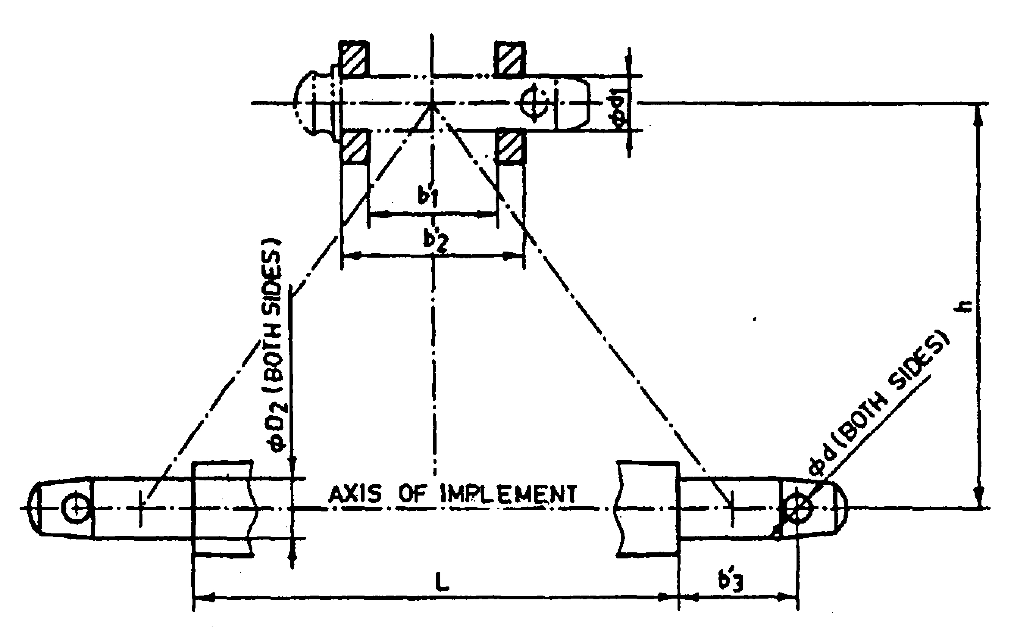
Fig. 1 : Implement Hitch Attachment

2.9 | Power transmission system:
 | a) |  |  | Method of transmission | :
2.9.1 |  | Spline end of rotavator input shaft: |  |  |  |  | Ref. Fig.2
 |  | a) | PTO Type 1/2/3 |  | :
 |  | b) | Nominal speed (rpm) |  | :
 |  | c) | Nominal dia.(mm) |  | :
 |  | d) | Number and type of splines |  | :

Dimension of Implement Power Input Shaft As per IS: 4931-2006

Specification/ Notations  (Refer Fig.2) | Measurement Dimensions (mm)
D Φ
d Φ
B Φ
A Φ
W
a
b
c
x
B
h

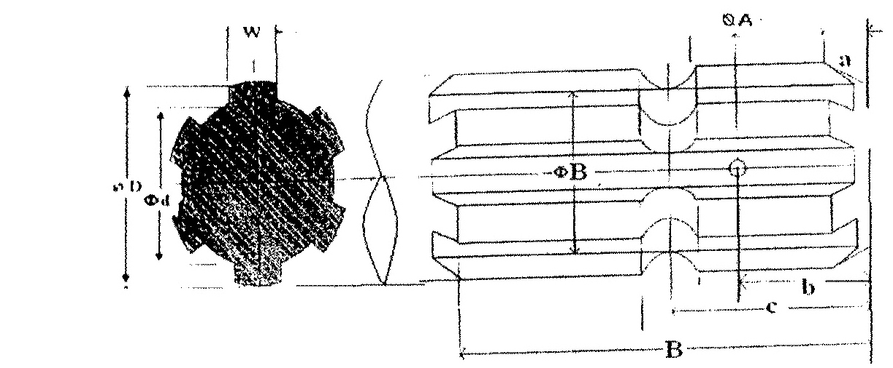

Fig. 2 Dimension of Implement Power Input Shaft

2.9.2 | Gear box assembly (primary reduction):
 | a) | Type | :
 | b) | No. of teeth on pinion
 | c) | No. of teeth on bevel gear | :
 | d) | Reduction ratio at gear box | :
 | e) | Oil capacity (L) | :
 | f) | Oil change period (hr) | :
 | g) | Recommended grade of oil
 | h) | Length of power transmission shaft (mm) (from gear box to secondary reduction unit
 | i) | Diameter of shaft (mm)
 | j) | Provision of breather
 | k) | No. of bearing
2.9.3 | Gear box assembly (secondary reduction):
 | a) | Type
 | b) | No. of teeth on drive gear
 | c) | No. of teeth on driven gear
 | d) | Reduction ratio
 | e) | No. of teeth on idler gear
 | f) | Oil capacity (L)
 | g) | Oil change period (hrs.)
 | h) | No. of bearing
2.9.4 | Propeller shaft:
 | a) | Type and material
 | b) | Length of shaft (mm)
 |  | Minimum
 |  | Maximum
 | c) | Mass of shaft (kg)
 | d) | Provision for locking

Propeller Shaft Insert Dimensions As per IS: 4931-2006

Sr. | Notations  (Refer Fig.3)
1 | D Φ
2 | d Φ
3 | W
4 | B
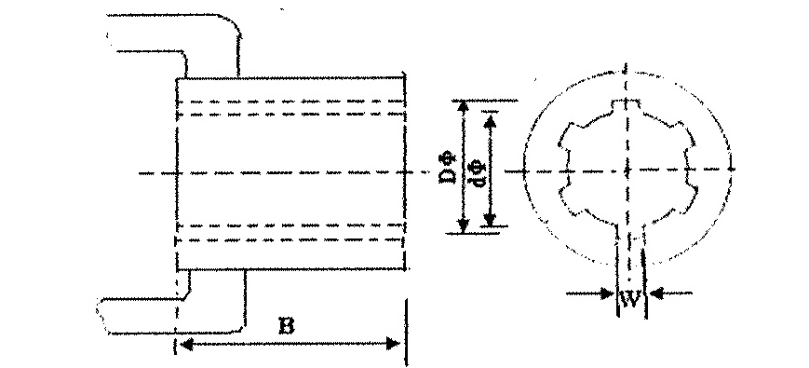
Fig. 3 : Propeller Shaft Insert Dimensions

2.9.5 | Safety clutch/device:
 | Size of bolt(mm) : |  | :
 | a) | Length | :
 | b) | Dia. | :
 | c) | Pitch | :
3.0 | Overall Dimensions (mm)
 | a) | Length | :
 | b) | Width | :
 | c) | Height | :
 | d) | Mass, (kg) | :
4.0 | Color of implement

5.0 | Details of Material of Construction :
Sr. | Name of part | Material | Section or size in mm
1 | 2 | 3 | 4
1 | Chassis
2 | Side support
3 | Shield (cover)
4 | Trailing board
5 | Rotor shaft
6 | Rotor blade
7 | Skid
8 | Adjusting rack

Place:
Date:
Signature : _________________________

Name : _________________________

Designation: ________________________

